**18-875/19-739 Engineering and Economics of Electric Energy Systems Take Home Final Exam Due May 15, 2020**

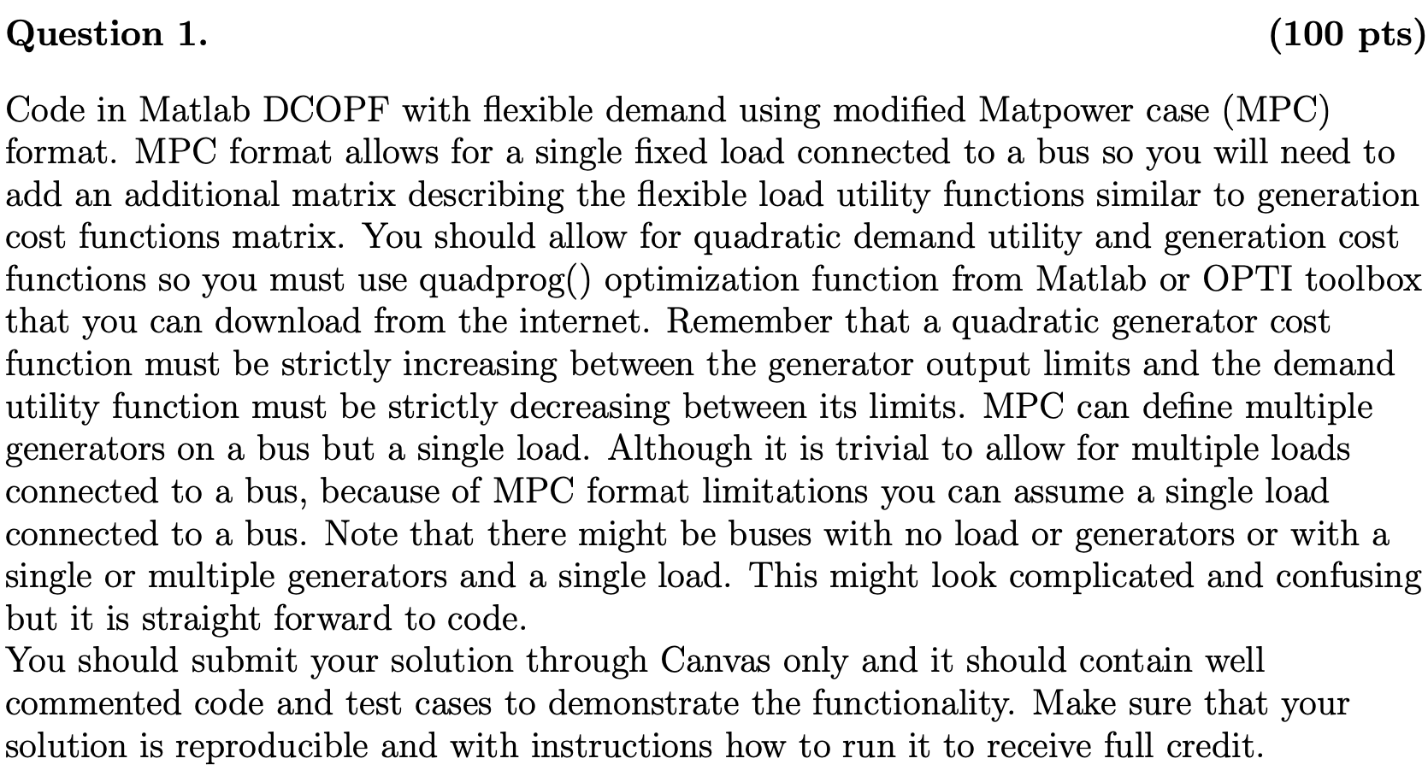

In this project, we are asked to write DCOPF with flexible demand using a modified MATPOWER case. We can add a matrix to describe the demand curve which similar to the generation cost function matrix.

I used the formulation provided by the lecture slides to code my DCOPF with fixed generation first.

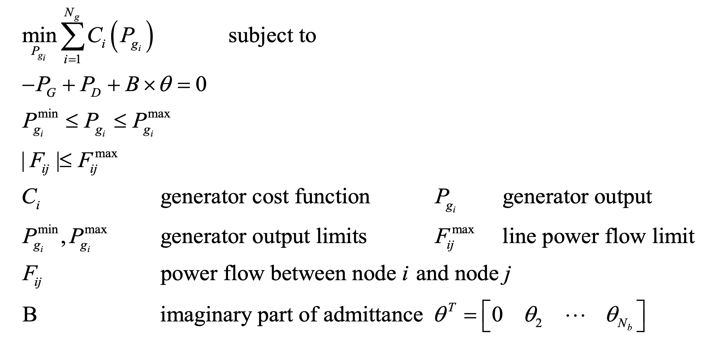

To make sure my DCOPF algorithm is correct, I compared my result with MATPOWER DCOPF results with a fixed load first. I used three cases to verify my answer, case 9, case 14, and case 30.

Case 9: Case 14:

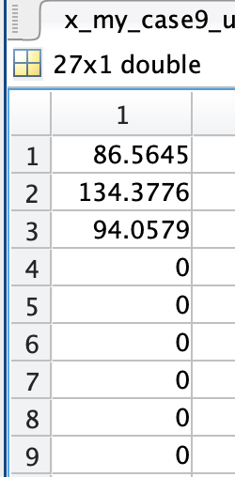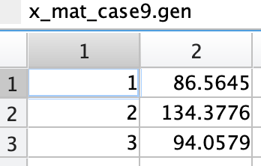 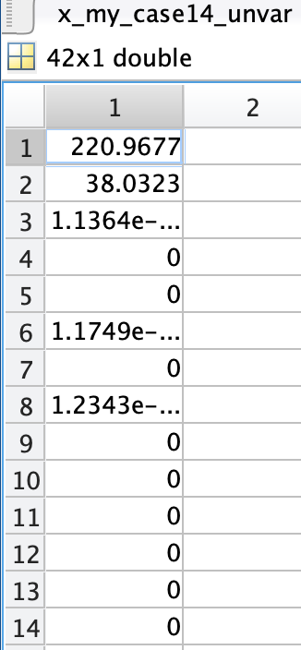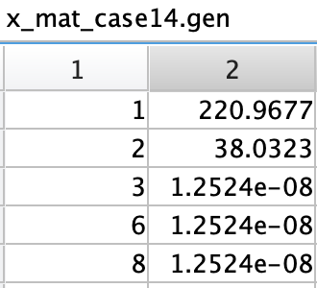

Case 30

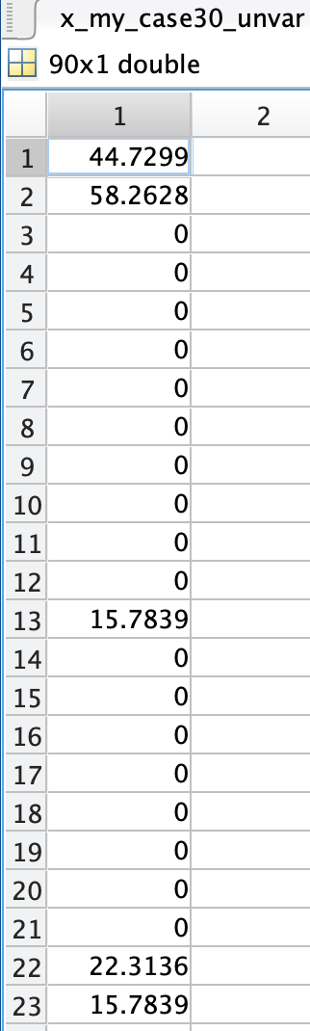 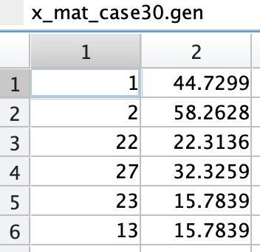



We can find the results are matched. Next, I adapted this algorithm to fit the flexible load function. We just need to make small adaptions to the original algorithm by changing the demands from fixed constants to variables.

In previous formulation, the demand is fixed value. Now, Pd is flexible and it becomes one of the variables. Our variables are [Pg, Pd, θ].

The objective function is:

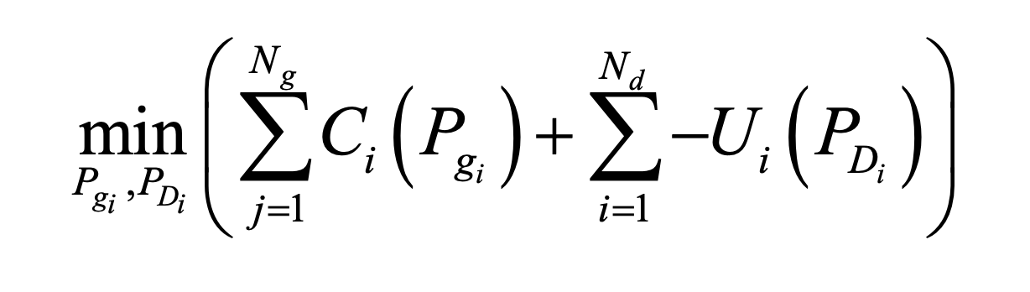

Since the demand function is strictly decreasing in our case, we don’t need the negative sign now. And the objective becomes:

Min

Where Pg is power generation for each generator and Pd is the demand for each load, and C,c is constant which can be ignored for optimization purposes.

The total generation cost = and it is strictly increasing.

The total demand cost = and it is strictly decreasing.

If we take a derivative with respect to the generation, we can get the generation price. It represents what is the generation price for the next 1 MW produced by the current generator. Same way, we can get the demand price for another 1 MW at the current bus.

The followings are the flexible load utility functions I added for each case.

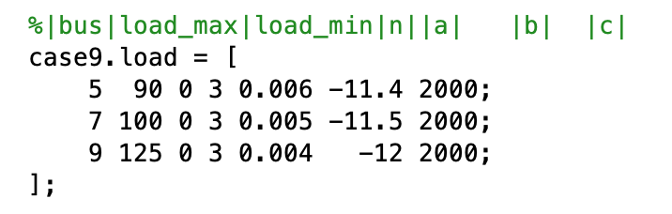

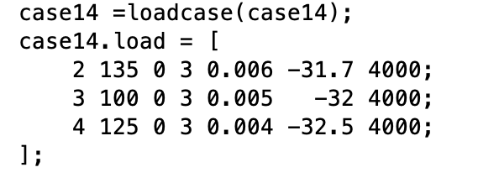

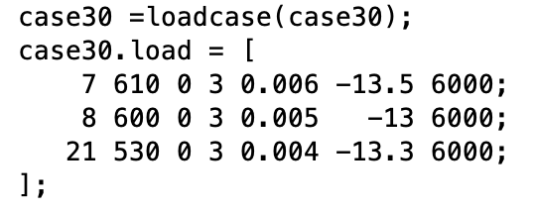

The generation price will increase as the generation increase. On the contrary, the demand price will decrease as the demand increase. It’s plausible because the generation will use more expensive energy sources and the demand will increase since price become cheaper.

Next, the results will be presented.

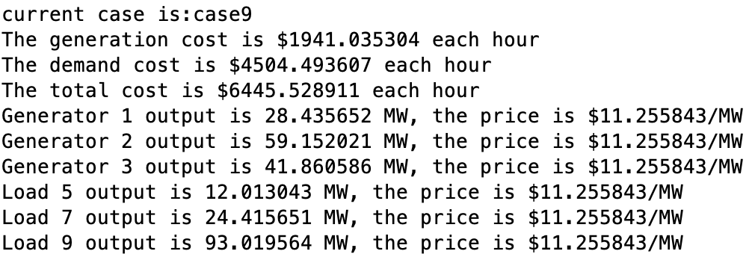

If the generators are not at limits and the transmission line is not congestion, we can see the demand price and generator price are all the same when the problem is optimal.

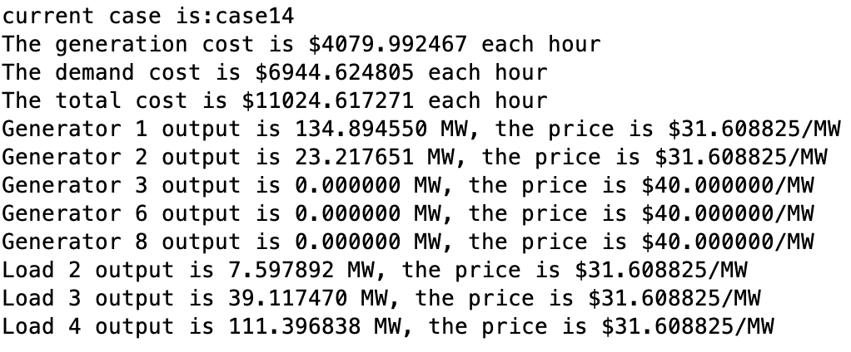

A similar thing happened to case14. Generator 1 and 2 are the only two generators are open, and they have the same price as the demand price.

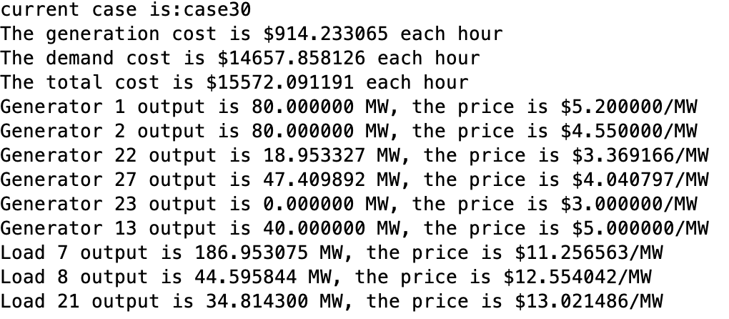

Since the transmission congestion and generator 1 ,2 are exhausted in case 30, the prices of each load and generator are not the same.

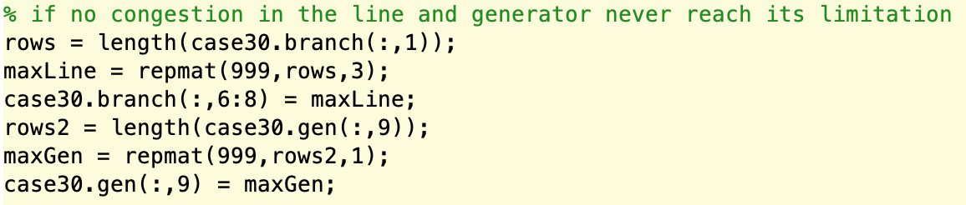

Then, I tried to remove all the constraints and run it again.

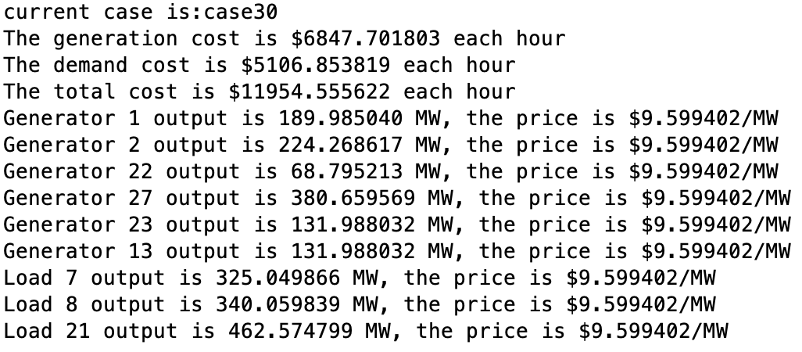

We can find the prices are the same for all the generators and loads and my thought has proved.

It is good idea to set the load as a variable without separate them in different periods and it is quite useful and can be applied in many situations.